WP Final Project

**DIGITAL AGENCY**

|  |  |
| --- | --- |
| Roll No. **A089** | Name: **Angad Preet Singh Gadhok** |
| Class: **BTech IT** | Batch: **A3** |
| Semester: **III** | Subject: **WEB PROGRAMMING** |

**Project Name: Digital Agency.**

**Project Goal and Description:**

* **Digital Agency** is a company that provides strategic direction, creative design, and technical development for screen-based products and services.
* What will my Digital Agency website provide?
* Digital templates for the clients website.
* Logo design for the client.
* Flyer designs to promote the client.
* Designing id’s for the employees or any other social events.
* Creating customised logos and posters, catering to the clients needs.
* Now the question arises, What new am I trying to bring to this fast paced and competitive business?
* Through this website we will listen to the needs and the queries of the clients.
* All the designs will be exclusive for the clients.
* Services will be provided at a nominal fee.
* Live demos of clients designs.
* Now may come the question of my experience and portfolio!
* That we will share through my artworks, past experiences, current work and mock template designs.

**HTML CODES for the 5 Web Pages:**

**Page 1: Wp final pro(1.0)**

<!DOCTYPE html>

<html>

<head>

<title>Digital Agency</title>

<link rel="shortcut icon" type="image/x-icon" href="logo-01.png">

<style>

body{

background-color: #212121;

background-image: url("snow.png");

}

input{

background-color: grey;

color: white;

padding: 14px 20px;

border: none;

border-radius: 4px;

}

.hov1:hover{

color:gold;

}

input[type=submit],input[type=reset]:hover{

color:white;

background-color: gold;

border-radius: 10px;

}

/*input[type=text]:hover{

width:450px;

transition: 15s;

transition-timing-function: ease;

}*/

</style>

<script>

function load(){

alert("Welcome to Digital Agency");

}

</script>

</head>

<body onload="load()">

<p style="text-align: center;">

<img src="taurus logo-01.png" alt="Logo" style="width:30%;">

</p>

<div align="center">

<fieldset style="width:30%;color:#FFD700;font-family: Montserrat; border-width: 3px">

<legend style="color:#FFD700; font-size:33px; font-family:nasalization;,font-weight: bold;" title="DIGITAL AGENCY"> DIGITAL AGENCY</legend><br>

<table>

<tr>

<form action="conn.php" method="post" target="_blank">

<td><label for="fname"> Enter your Name:</label></td>

<td><input type="text" id="fname" name="fname" ></td>

</tr>

<tr>

<td><br></td>

<td></td>

</tr>

<tr>

<td><label for="eid"> Enter your Email-Id:</label></td>

<td><input type="email" id="eid" name="eid" ></td>

</tr>

<tr>

<td><br></td>

<td></td>

</tr>

<tr>

<td><label for="pass"> Create new password:</label></td>

<td><input type="password" id="pass" name="pass"></td>

</tr>

<tr>

<td><br></td>

<td></td>

</tr>

<tr>

<td><label for="pass"> Re-Enter new password:</label></td>

<td><input type="password" id="pass" name="pass"></td>

</tr>

<tr>

<td><br></td>

<td></td>

</tr>

<tr class="hov1">

<td class="hov1">

<input type="submit" value="Sign up">

</td>

<td class="hov1">

<input type="reset" value="Reset">

</td>

</tr>

</form>

</table><br>

<a href="Wp final pro(2.0).html" style="color: gold;font-size:18px;text-decoration: none; "><b>or LOG IN AS GUEST</b></a>

</fieldset>

</div>

<div style="position: bottom;color: gold;text-align: center; /*background-color:#212121;*/">

<table>

<tr>

<td><img src="social-01.png" style="width:330px; height: 250px "></td>

<td>&copy;2020 DIGITAL AGENCY All Rights Reserved</td>

</tr>

</table>

</div>

</body>

</html>

**Page 2: Wp final pro(2.0)**

<!DOCTYPE html>

<html>

<head>

<title>HOME Page</title>

<link rel="stylesheet" type="text/css" href="cssstyling.css">

<script type="text/javascript" src="javascript.js"></script>

<link rel="shortcut icon" type="image/x-icon" href="logo-01.png">

<style>

/*body{

background-color: #000000;

font-family: Montserrat;

font-size: 18px;

}*/

/*.class1{

background-color:#212121;

padding: 10px;

text-align: center;

font-weight: bold;

}*/

.class2{

color:white;

}

.class3{

text-align: center;

width:40%;

padding: 5%;

width:25%;

}

.class3:hover{

font-size:19px;

transition:3s;

color:white;

}

.class4{

text-align: center;

width:100%;

font-weight: bold;

font:21px;

font-family: monsterrat;

}

.class4:hover{

font-size:25px;

transition:3s;

color:white;

}

.class5{

color:gold;

font-size:20px;

font-weight:bold;

text-align: center;

}

.class5:hover{

color:white;

}

</style>

<script>

function load(){

alert("Welcome to our Home Page");

}

</script>

</head>

<body onload="load(),img(0)">

<!--<p style="font-family:nasalization;color: gold;font-size: 30px;font-weight: bold;">

<img src="taurus logo-01.png" width="130" height="100">Digital Agency

</p>-->

<table>

<tr style="text-align: center;">

<td><img src="taurus logo-01.png" width="130" height="100"></td>

<td ><a href="Wp final pro(2.0).html" style="font-family:nasalization;color: gold;font-size: 35px;font-weight: bold;">Digital Agency</a></td>

</tr>

</table>

<table style="width: 100%;border-collapse: collapse;">

<tr class="class1">

<td> <a href="Wp final pro(2.0).html" title="Home">HOME</a></td>

<td><a href="Wp final pro(3.0).html" title="Design">DESIGN</a></td>

<td><a href="Wp final pro(4.0).html" title="Partners">PARTNERS</a></td>

<td><a href="Wp final pro(5.0).html" title="Contact Us">CONTACT US</a></td>

<td><a href="Wp final pro(1.0).html" target="_blank" title="Sign in">SIGN IN</a></td>

</tr>

</table><br><br>

<table style="width:100%">

<tr style="font-size: 16px">

<th style="background-color: #ffee70;" class="class3">BRANDING</th>

<th style="background-color: #ffe433;" class="class3">GRAPHIC DESIGNING</th>

<th style="background-color: #ffdd1f;" class="class3">MARKETING STRATEGY</th>

<th style="background-color: #ffda0a;" class="class3">DIGITAL ADVERTISEMENT</th>

</tr>

</table>

<p style="color:gold;font-size:25px;font-weight:bold;">What Is A Digital Agency?</p>

<div class="class2">

<pre>

<b>In simple terms, a Digital Agency is an advertising agency that has evolved to meet the changing needs of marketing in the digital age.</b>

<b>Digital Agencies bring graphic design and copywriting together with new technology and modern marketing techniques. The result is a highly creative mix

of artistry, science, engineering and determination to fix problems and find solutions in a very fast-changing landscape.<b></div>

</pre>

<p style="color:gold;font-size:25px;font-weight:bold;">What Do We Do?</p>

<table style="width:100%">

<tr style="font-size: 16px">

<th style="background-color: #0096c7;" class="class3">We Teach</th>

<th style="background-color: #0077b6;" class="class3">We Learn</th>

<th style="background-color: #023e8a;" class="class3">We Grow</th>

<th style="background-color: #03045e;" class="class3">We Believe</th>

</tr>

</table><br><br>

</div>

<p style="color:gold;font-size:25px;font-weight:bold;">What Do We Teach?</p>

<div style="align-items: center">

<img src="original.jpg" width=100% height="650" id="1">

<img src="works2.png" width=100% height="650" id="2">

<img src="works3.png" width=100% height="650" id="3">

<img src="works1.png" width=100% height="650" id="4">

</div>

<div style="text-align: center;">

<form>

<input type="radio" name="photo" onclick="img(0)" checked>

<input type="radio" name="photo" onclick="img(1)">

<input type="radio" name="photo" onclick="img(2)">

<input type="radio" name="photo" onclick="img(3)">

</form>

</div>

<table style="width:100%">

<tr style="font-size: 16px">

<th>

<input type="button" name="button" value="PHOTOSHOP" class="class4" style="background-color: #5390d9;padding:70px; "

onclick="img(3)">

</th>

<th>

<input type="button" name="button" value="ILLUSTRATOR" class="class4" style="background-color: #fba164;padding:70px; "

onclick="img(1)">

</th>

<th>

<input type="button" name="button" value="INDESIGN" class="class4" style="background-color: #f886a8;padding:70px; "

onclick="img(2)">

</th>

<th>

<input type="button" name="button" value="PREMIERE PRO" class="class4" style="background-color: #7400b8;padding:70px; "

onclick="img(0)">

</th>

</tr>

</table><br><br>

<p style="color:gold;font-size:25px;font-weight:bold;">How Do We Grow?</p>

<p style="color:white;">Blog Site From Our Partners:</p>

<embed type="text/html" src="https://thehomelandtalesbyveeb.blogspot.com/?m=1" width=100% height="650">

<div style="background-color: #5a189a">

<p class="class5" title="Our Moto">OUR MOTO:</p>

<p class="class5" style="font-size:40px;">DREAM IT, DO IT!</p>

</div>

<a href="Wp final pro(3.0).html" >

<p style="text-decoration: none;text-align: center;">Click here for Our Exclusive Design Page.</p>

</a>

<div style="position: bottom;color: gold;text-align: center; /*background-color:#212121;*/">

<table>

<tr>

<td><img src="social-01.png" style="width:330px; height: 250px "></td>

<td>&copy;2020 DIGITAL AGENCY All Rights Reserved</td>

</tr>

</table>

</div>

</body>

</html>

**Page 3: Wp final pro(3.0)**

<!DOCTYPE html>

<html>

<head>

<title>Design</title>

<link rel="stylesheet" type="text/css" href="cssstyling.css">

<script type="text/javascript" src="javascript.js"></script>

<link rel="shortcut icon" type="image/x-icon" href="logo-01.png">

<style>

.img1{

text-align: left;

}

p{

color:#FFD700;

}

/*.class1{

background-color:#212121;

padding: 10px;

text-align: center;

font-weight: bold;

}*/

div.class2 {

background-color: #333;

overflow: auto;

white-space: nowrap;

}

div.class2 img {

display: inline-block;

color: white;

text-align: center;

padding: 0px;

text-decoration: none;

}

.class3{

text-align: center;

width:40%;

padding: 5%;

width:25%;

}

.class3:hover{

font-size:19px;

transition:3s;

color:white;

}

.class4:hover{

color:white;

}

</style>

<script>

function load(){

alert("Welcome to our Design Page");

}

</script>

</head>

<body onload="load(),tag(0)">

<table>

<tr style="text-align: center;">

<td><img src="taurus logo-01.png" width="130" height="100"></td>

<td ><a href="Wp final pro(2.0).html" style="font-family:nasalization;color: gold;font-size: 35px;font-weight: bold;">Digital Agency</a></td>

</tr>

</table>

<table style="width: 100%;border-collapse: collapse;">

<tr class="class1">

<td> <a href="Wp final pro(2.0).html" title="Home">HOME</a></td>

<td><a href="Wp final pro(3.0).html" title="Design">DESIGN</a></td>

<td><a href="Wp final pro(4.0).html" title="Partners">PARTNERS</a></td>

<td><a href="Wp final pro(5.0).html" title="Contact Us">CONTACT US</a></td>

<td><a href="Wp final pro(1.0).html" target="_blank" title="Sign in">SIGN IN</a></td>

</tr>

</table><br><br>

</div>-->

<p style="font-weight: bold;text-align: center;font-size: 30px" class="class4">OUR EXCLUSIVE DESIGNS</p>

<table style="width:100%">

<tr style="font-size: 16px">

<th style="background-color: #e0aaff;" class="class3">LOGOS</th>

<th style="background-color: #c77dff;" class="class3">POSTERS</th>

<th style="background-color: #9d4edd;" class="class3">VIDEOS</th>

<th style="background-color: #7b2cbf;" class="class3">TEMPLATES</th>

</tr>

</table><br><br>

<p style="font-weight: bold;text-align: center;font-size: 30px" class="class4">CARAOUSEL ARTWORKS</p><br>

<div class="class2">

<img src="Tinder-01.png" style="width: 200px;height: 200px;">

<img src="Tinder-02.png" style="width: 200px;height: 200px;">

<img src="Tinder-03.png" style="width: 200px;height: 200px;">

<img src="Tinder-04.png" style="width: 200px;height: 200px;">

<img src="Tinder-05.png" style="width: 200px;height: 200px;">

<img src="Tinder-06.png" style="width: 200px;height: 200px;">

<img src="Tinder-07.png" style="width: 200px;height: 200px;">

<img src="Tinder-08.png" style="width: 200px;height: 200px;">

<img src="Tinder-09.png" style="width: 200px;height: 200px;">

</div><br><br><br>

<div class="class2">

<img src="pubg_001.png" style="width: 200px;height: 200px;">

<img src="pubg_002.png" style="width: 200px;height: 200px;">

<img src="pubg_003.png" style="width: 200px;height: 200px;">

<img src="pubg_004.png" style="width: 200px;height: 200px;">

<img src="pubg_005.png" style="width: 200px;height: 200px;">

<img src="pubg_006.png" style="width: 200px;height: 200px;">

<img src="pubg_007.png" style="width: 200px;height: 200px;">

<img src="pubg_008.png" style="width: 200px;height: 200px;">

<img src="pubg_009.png" style="width: 200px;height: 200px;">

</div><br><br><br>

<p style="font-weight: bold;text-align: center;font-size: 30px" class="class4">LOGO VARIANTS</p><br><br>

<div>

<table>

<tr>

<td style="width: 50%">

<video class="video" src="batman.mp4" width="745px" height="550px" controls> </video>

</td>

<td style="width:50%">

<img src="BATMAN-01.PNG" width="745px" height="550px">

</td>

</tr>

<tr>

<td>

<img src="ghost.gif" width="745px" height="550px">

</td>

<td>

<img src="ghost logo.jpg" width="745px" height="550px">

</td>

</tr>

</table>

</div><br>

<p style="font-weight: bold;text-align: center;font-size: 30px" class="class4">POSTER DESIGNS</p>

<div style="text-align: center;">

<form>

<input type="radio" name="photo" onclick="tag(0)" checked>

<input type="radio" name="photo" onclick="tag(1)">

<input type="radio" name="photo" onclick="tag(2)">

</form>

</div>

<img src="black.jpg" width=100% height=700 id="1">

<img src="red.jpg" width=100% height=700 id="2">

<img src="hall-01.png" width=100% height=700 id="3"><br><br>

<p style="font-weight: bold;text-align: center;font-size: 30px" class="class4">TO GET THOSE DESIGN DREAMS COME TRUE<br>

<a href="Wp final pro(5.0).html"><p style="text-decoration: none;text-align: center;font-weight: bold;">Click here to Contact Us.</p></a></p>

<div style="position: bottom;color: gold;text-align: center;">

<table>

<tr>

<td><img src="social-01.png" style="width:330px; height: 250px "></td>

<td>&copy;2020 DIGITAL AGENCY All Rights Reserved</td>

</tr>

</table>

</div>

</body>

</html>

**Page 4: Wp final pro(4.0)**

<!DOCTYPE html>

<html>

<head>

<title>PARTNERS</title>

<link rel="stylesheet" type="text/css" href="cssstyling.css">

<script type="text/javascript" src="javascript.js"></script>

<link rel="shortcut icon" type="image/x-icon" href="logo-01.png">

<style>

.class2{

color:white;

}

.class3{

text-align: center;

width:40%;

padding: 5%;

width:25%;

}

.class3:hover{

font-size:19px;

transition:3s;

color:white;

}

.class4{

color:gold;

text-align: center;

width:100%;

font-weight: bold;

font:21px;

}

.class4:hover{

color:white;

}

</style>

<script>

function load(){

alert("Our Partners.");

}

</script>

</head>

<body onload="load();logo(0)">

<table>

<tr style="text-align: center;">

<td><img src="taurus logo-01.png" width="130" height="100"></td>

<td ><a href="Wp final pro(2.0).html" style="font-family:nasalization;color: gold;font-size: 35px;font-weight: bold;">Digital Agency</a></td>

</tr>

</table>

<table style="width: 100%;border-collapse: collapse;">

<tr class="class1">

<td> <a href="Wp final pro(2.0).html" title="Home">HOME</a></td>

<td><a href="Wp final pro(3.0).html" title="Design">DESIGN</a></td>

<td><a href="Wp final pro(4.0).html" title="Partners">PARTNERS</a></td>

<td><a href="Wp final pro(5.0).html" title="Contact Us">CONTACT US</a></td>

<td><a href="Wp final pro(1.0).html" target="_blank" title="Sign in">SIGN IN</a></td>

</tr>

</table><br><br>

<p style="font-weight: bold;text-align: center;font-size: 30px;" class="class4" title="Finbits India">FINBITS INDIA</p>

<embed type="text/html" src="https://www.finbitsindia.com/" width=100% height="650"><br><br><br>

<p style="font-weight: bold;text-align: center;font-size: 30px;" class="class4" title="Partners">EXCLUSIVE PARTNERS</p>

<!--<table style="width: 100%">

<tr>

<td>

<img src="logo1.png" width="400px" height="115px">

</td>

<td>

<img src="logo2.jpg" width="400px" height="200px">

</td>

<td>

<img src="logo7.png" width="340px" height="240px">

</td>

</tr>

<tr>

<td>

<img src="logo5.png" width="400px" height="240px">

</td>

<td>

<img src="logo6.jpeg" width="355px" height="240px">

</td>

<td>

<img src="logo4.jpeg" width="400px" height="90px">

</td>

</tr>

</table>-->

<table width="100%" >

<tr>

<td style="text-align: center;padding: 80px">

<form>

<input type="radio" name="log" onclick="logo(0)" checked><br>

<input type="radio" name="log" onclick="logo(1)"><br>

<input type="radio" name="log" onclick="logo(2)"><br>

<input type="radio" name="log" onclick="logo(3)"><br>

<input type="radio" name="log" onclick="logo(4)"><br>

</form>

</td>

<td style="text-align: center;padding: 200px;">

<img src="02.png" width="700px" height="420px" id="1">

<img src="03.png" width="700px" height="450px" id="2">

<img src="04.png" width="700px" height="470px" id="3">

<img src="05.png" width="700px" height="220px" id="4">

<img src="01.png" width="700px" height="420px" id="5">

</td>

</table><br><br>

<p style="font-weight: bold;text-align: center;font-size: 30px;" class="class4" title="Partners">Get in Touch with us and Lets grow together.<br><a href="Wp final pro(5.0).html">Click here to Contact Us.</a></p>

<div style="position: bottom;color: gold;text-align: center;">

<table>

<tr>

<td><img src="social-01.png" style="width:330px; height: 250px "></td>

<td>&copy;2020 DIGITAL AGENCY All Rights Reserved</td>

</tr>

</table>

</div>

</body>

</html>

**Page 5: Wp final pro(5.0)**

<!DOCTYPE html>

<html>

<head>

<title>CONTACT US</title>

<link rel="stylesheet" type="text/css" href="cssstyling.css">

<script type="text/javascript" src="javascript.js"></script>

<link rel="shortcut icon" type="image/x-icon" href="logo-01.png">

<style>

.class2{

color:white;

font:16px;

}

.class3{

text-align: center;

width:40%;

padding: 5%;

width:25%;

}

.class3:hover{

font-size:19px;

transition:3s;

color:white;

}

.class4{

color:gold;

text-align: center;

width:100%;

font-weight: bold;

font:30px;

}

.class4:hover{

color:white;

}

input,textarea{

color: white;

padding: 20px 100px;

border: 0;

outline: 0;

background: transparent;

border-bottom: 1px solid white;

}

input[type=submit],input[type=reset]:hover{

color:white;

border-radius: 20px;

padding: 15px;

border:1px solid white;

}

.hov1:hover{

color:gold;

}

</style>

<script>

function load(){

alert("Get in Touch with Us.");

}

</script>

</head>

<body onload="load()">

<table>

<tr style="text-align: center;">

<td><img src="taurus logo-01.png" width="130" height="100"></td>

<td ><a href="Wp final pro(2.0).html" style="font-family:nasalization;color: gold;font-size: 35px;font-weight: bold;">Digital Agency</a></td>

</tr>

</table>

<table style="width: 100%;border-collapse: collapse;">

<tr class="class1">

<td> <a href="Wp final pro(2.0).html" title="Home">HOME</a></td>

<td><a href="Wp final pro(3.0).html" title="Design">DESIGN</a></td>

<td><a href="Wp final pro(4.0).html" title="Partners">PARTNERS</a></td>

<td><a href="Wp final pro(5.0).html" title="Contact Us">CONTACT US</a></td>

<td><a href="Wp final pro(1.0).html" target="_blank" title="Sign in">SIGN IN</a></td>

</tr>

</table><br><br>

<p style="font-weight: bold;text-align: center;font-size: 30px;" class="class4">Get in Touch with us and let your Dreams come True!</p>

<p style="font-weight: bold;text-align: center;font-size: 26px;" class="class4" title="Details">Our Contact Details:</p>

<table style="width:100%">

<tr style="font-size: 16px">

<th>

<input type="button" name="button" value="INSTAGRAM" class="class4" style="color:white;background-color: #5a189a;padding:60px; "

onclick="window.location.href='https://www.instagram.com/';">

</th>

<th>

<input type="button" name="button" value="LINKDIN" class="class4" style="color:white;background-color: #0077b6;padding:60px;"

onclick="window.location.href='https://in.linkedin.com/';">

</th>

<th>

<input type="button" name="button" value="TWITTER" class="class4" style="color:white;background-color: #48cae4;padding:60px; "

onclick="window.location.href='https://twitter.com/?lang=en';">

</th>

<th>

<input type="button" name="button" value="YOUTUBE" class="class4" style="color:white;background-color: #90e0ef;padding:60px; "

onclick="window.location.href='https://www.youtube.com/';">

</th>

</tr>

</table><br><br>

<p style="font-weight: bold;text-align: center;font-size: 30px;" class="class4" title="Finbits India">LET'S CONNECT!

</p>

<pre class="class2">When there are great ideas at stake, it's always a good idea to share. Tell us how can we make it happen for you!

Fill the form below or mail us at <a href="https://mail.google.com/mail/">business@digital-agency.in</a></pre>

<div align="center">

<table style="align-content: center;width: 100%;">

<form action="conn2.php" method="post" target="_blank">

<tr >

<td style="width:745px;padding: 0px 0px 0px 50px; "><input type="text" id="name" name="name" placeholder="Name"></td>

<td style="width:745px "><p style="font-weight: bold;font-size: 26px;" class="class4" title="Details">SUBSCRIBE</p></td>

</tr>

<tr>

<td style="padding: 0px 0px 0px 50px; "><input type="email" id="mail" name="mail" placeholder="Email address"></td>

<td class="class2">Sign up for our weekly newsletter and discover what's brewing in the world of digital media.

</td>

</tr>

<tr>

<td style="padding: 0px 0px 0px 50px; "><input type="text" id="num" name="num" placeholder="Number"></td>

<td ><a href="https://www.morningbrew.com/">Click here to Subscribe!</a></td>

</tr>

<tr>

<td style="padding: 0px 0px 0px 50px; "><input type="text" id="loc" name="loc" placeholder="Location(city)"></td>

</tr>

<tr>

<td style="padding: 0px 0px 0px 50px; "><textarea id="area" name="area" placeholder="Message"></textarea></td>

</tr>

<tr>

<td class="hov1" style="padding: 10px 0px 0px 50px; "><input type="submit" value="Submit"></td>

</tr>

</form>

</table>

</div><br><br><br>

<p style="font-weight: bold;text-align: center;font-size: 30px;" class="class4">Go Back to our Home Page for more Content</p>

<a href="Wp final pro(2.0).html"><p style="text-align: center;">Click here for the Home Page.</p></a>

<div style="position: bottom;color: gold;text-align: center;">

<table>

<tr>

<td><img src="social-01.png" style="width:330px; height: 250px "></td>

<td>&copy;2020 DIGITAL AGENCY All Rights Reserved</td>

</tr>

</table>

</div>

</body>

</html>

**EXTERNAL CSS FILE:** **cssstyling.css**

body{

background-color: #000000;

font-family: Montserrat;

font-size: 18px;

}

.class1{

background-color:#212121;

padding: 10px;

text-align: center;

font-weight: bold;

}

a{

color:#FFD700;

font-family: Montserrat;

text-decoration:none;

}

img{

text-align: left;

}

a:hover{

color:white;

font-size:20px;

}

a:visited{

color:purple;

font-size:20px;

}

a:active{

color:grey;

}

**JAVASCRIPT FILE: javascript.js**

function img(x)

{

if (x==0)

{

document.getElementById('1').style.display='block';

document.getElementById('2').style.display='none';

document.getElementById('3').style.display='none';

document.getElementById('4').style.display='none';

document.getElementById('5').style.display='none';

}

else if (x==1)

{

document.getElementById('1').style.display='none';

document.getElementById('2').style.display='block';

document.getElementById('3').style.display='none';

document.getElementById('4').style.display='none';

document.getElementById('5').style.display='none';

}

else if (x==2)

{

document.getElementById('2').style.display='none';

document.getElementById('1').style.display='none';

document.getElementById('3').style.display='block';

document.getElementById('4').style.display='none';

}

else if (x==3)

{

document.getElementById('2').style.display='none';

document.getElementById('1').style.display='none';

document.getElementById('3').style.display='none';

document.getElementById('4').style.display='block';

/*document.getElementById('5').style.display='none';*/

}

/*else if (x==4)

{

document.getElementById('2').style.display='none';

document.getElementById('1').style.display='none';

document.getElementById('3').style.display='none';

document.getElementById('4').style.display='none';

document.getElementById('5').style.display='block';

}*/

else if (x==5)

{

document.getElementById('2').style.display='none';

document.getElementById('1').style.display='none';

document.getElementById('3').style.display='none';

document.getElementById('4').style.display='none';

document.getElementById('5').style.display='none';

}

}

function tag(x){

if (x==0)

{

document.getElementById('1').style.display='block';

document.getElementById('2').style.display='none';

document.getElementById('3').style.display='none';

}

else if (x==1)

{

document.getElementById('1').style.display='none';

document.getElementById('2').style.display='block';

document.getElementById('3').style.display='none';

}

else if (x==2)

{

document.getElementById('2').style.display='none';

document.getElementById('1').style.display='none';

document.getElementById('3').style.display='block';

}

else if (x==3)

{

document.getElementById('2').style.display='none';

document.getElementById('1').style.display='none';

document.getElementById('3').style.display='none';

}

}

function logo(x)

{

if (x==0)

{

document.getElementById('1').style.display='block';

document.getElementById('2').style.display='none';

document.getElementById('3').style.display='none';

document.getElementById('4').style.display='none';

document.getElementById('5').style.display='none';

}

else if (x==1)

{

document.getElementById('1').style.display='none';

document.getElementById('2').style.display='block';

document.getElementById('3').style.display='none';

document.getElementById('4').style.display='none';

document.getElementById('5').style.display='none';

}

else if (x==2)

{

document.getElementById('2').style.display='none';

document.getElementById('1').style.display='none';

document.getElementById('3').style.display='block';

document.getElementById('4').style.display='none';

}

else if (x==3)

{

document.getElementById('2').style.display='none';

document.getElementById('1').style.display='none';

document.getElementById('3').style.display='none';

document.getElementById('4').style.display='block';

document.getElementById('5').style.display='none';

}

else if (x==4)

{

document.getElementById('2').style.display='none';

document.getElementById('1').style.display='none';

document.getElementById('3').style.display='none';

document.getElementById('4').style.display='none';

document.getElementById('5').style.display='block';

}

else if (x==5)

{

document.getElementById('2').style.display='none';

document.getElementById('1').style.display='none';

document.getElementById('3').style.display='none';

document.getElementById('4').style.display='none';

document.getElementById('5').style.display='none';

}

}

**PHP CODES:**

**Database creation:**

<?php

$server="localhost";

$user="root";

$pw="";

$conn=mysqli_connect($server,$user,$pw);

if(!$conn)

echo "could not connect";

else{

echo "connection successful";

$sql1="CREATE DATABASE wpfinal";

if (mysqli_query($conn,$sql1))

echo "Datbase created successfully";

else

echo "Datbase not created successfully";

}

mysqli_close($conn);

?>

**Table 1 Creation:**

<?php

$server="localhost";

$user="root";

$pw="";

$dbname="wpfinal";

$conn=mysqli_connect($server,$user,$pw,$dbname);

if(!$conn)

echo "could not connect";

else{

$sql1="CREATE TABLE final(id INT(6) UNSIGNED AUTO_INCREMENT PRIMARY KEY,

fname VARCHAR(20) NOT NULL,

eid VARCHAR(20) NOT NULL,

pass VARCHAR(20))";

if (mysqli_query($conn,$sql1))

echo "TABLE created successfully";

else

echo "TABLE not created successfully";

}

mysqli_close($conn);

?>

**Table 2 Creation:**

<?php

$server="localhost";

$user="root";

$pw="";

$dbname="wpfinal";

$conn=mysqli_connect($server,$user,$pw,$dbname);

if(!$conn)

echo "could not connect";

else{

$sql1="CREATE TABLE final2(id INT(6) UNSIGNED AUTO_INCREMENT PRIMARY KEY,

name VARCHAR(20) NOT NULL,

mail VARCHAR(20) NOT NULL,

num VARCHAR(20) NOT NULL,

loc VARCHAR(20) NOT NULL,

area VARCHAR(20))";

if (mysqli_query($conn,$sql1))

echo "TABLE created successfully";

else

echo "TABLE not created successfully";

}

mysqli_close($conn);

?>

**Table 1 connection:**

<?php

$server="localhost";

$user="root";

$pw="";

$dbname="wpfinal";

$fname=$_POST["fname"];

$eid=$_POST["eid"];

$pass=$_POST["pass"];

$conn=mysqli_connect($server,$user,$pw,$dbname);

if(!$conn)

echo "could not connect";

else{

$sql1="SELECT * FROM final Where fname='$fname'";

$res=mysqli_query($conn,$sql1);

if (mysqli_num_rows($res)>0){

echo "Record valid<br>You have been Signed In<br>";

echo '<a href="Wp final pro(2.0).html">Click here to go to Home Page.</a>';

}

else{

$sql="INSERT INTO final(fname,eid,pass) VALUES('$fname','$eid','$pass')";

if (mysqli_multi_query($conn,$sql)){

echo "Value RECORD inserted successfully<br>You have been Signed In<br>";

echo '<a href="Wp final pro(2.0).html">Click here to go to Home Page.</a>';

}

else

echo "Value RECORD not inserted successfully";

}

}

header("location:Wp final pro(2.0).html");

mysqli_close($conn);

?>

**Table 2 connection:**

<?php

$server="localhost";

$user="root";

$pw="";

$dbname="wpfinal";

$name=$_POST["name"];

$mail=$_POST["mail"];

$num=$_POST["num"];

$loc=$_POST["loc"];

$area=$_POST["area"];

$conn=mysqli_connect($server,$user,$pw,$dbname);

if(!$conn)

echo "could not connect";

else{

$sql1="SELECT * FROM final2 Where name='$name'";

$res=mysqli_query($conn,$sql1);

if (mysqli_num_rows($res)>0){

echo "Value already Recorded <br>";

echo '<a href="Wp final pro(5.0).html">Click here to get back to the Page.</a>';

}

else{

$sql="INSERT INTO final2(name,mail,num,loc,area) VALUES('$name','$mail','$num','$loc','$area')";

if (mysqli_multi_query($conn,$sql))

{

echo "Value RECORD inserted successfully<br>";

echo '<a href="Wp final pro(5.0).html">Click here to get back to the Page.</a>';

}

else

echo "Value RECORD not inserted successfully";

}

}

header("location:Wp final pro(5.0).html");

mysqli_close($conn);

?>

**Screenshots:**

**Page 1:**

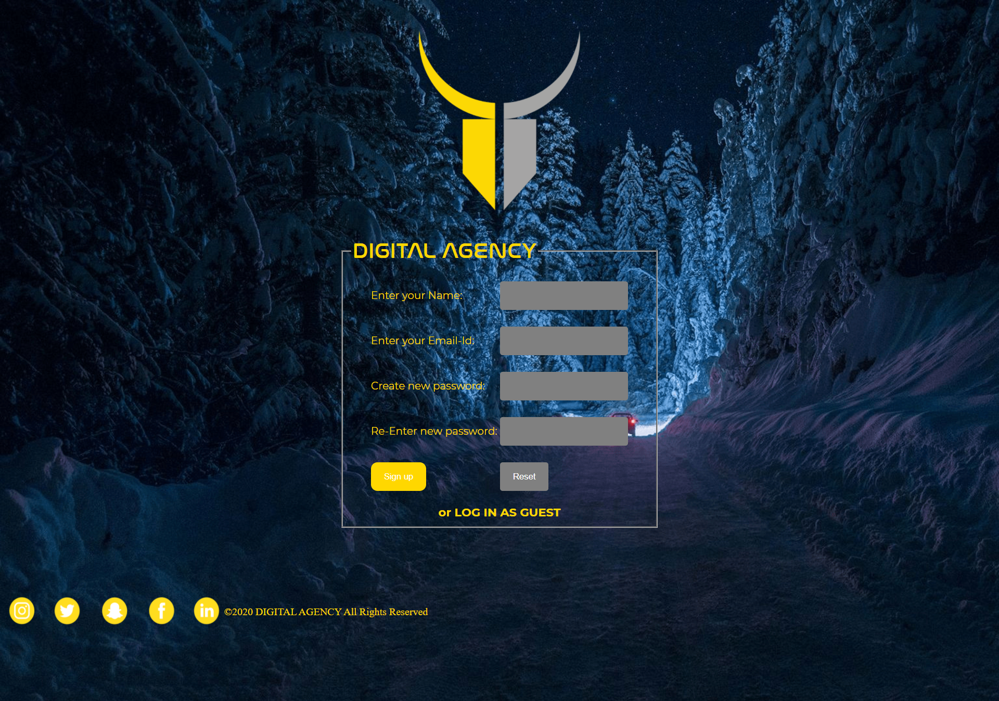

**Page 2:**

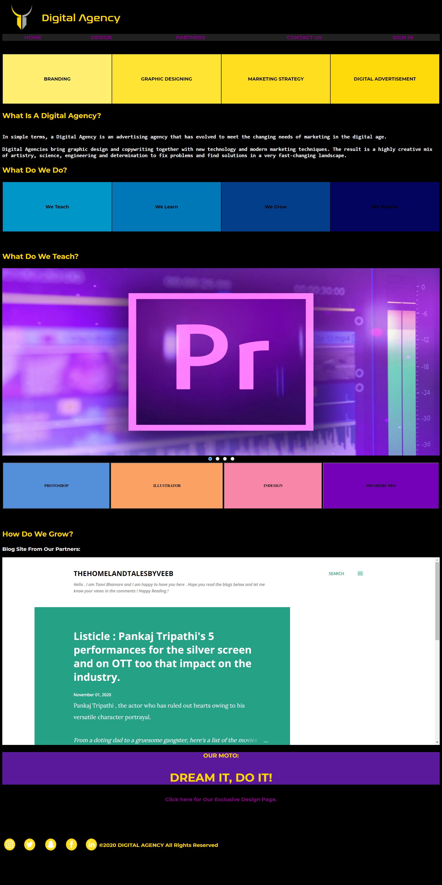

**Page 3:**

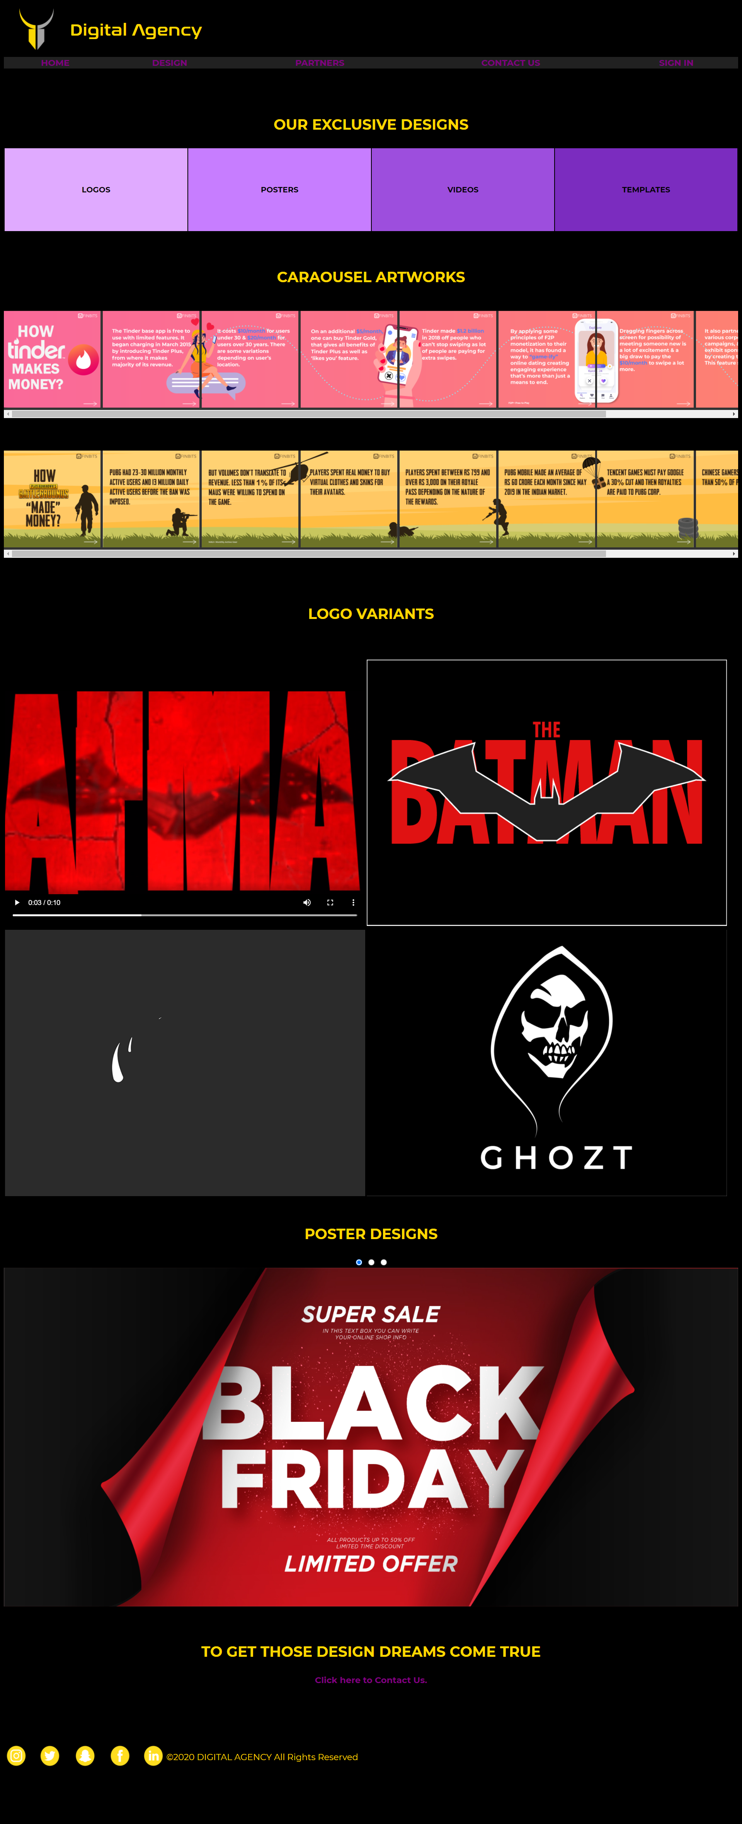

**Page 4:**

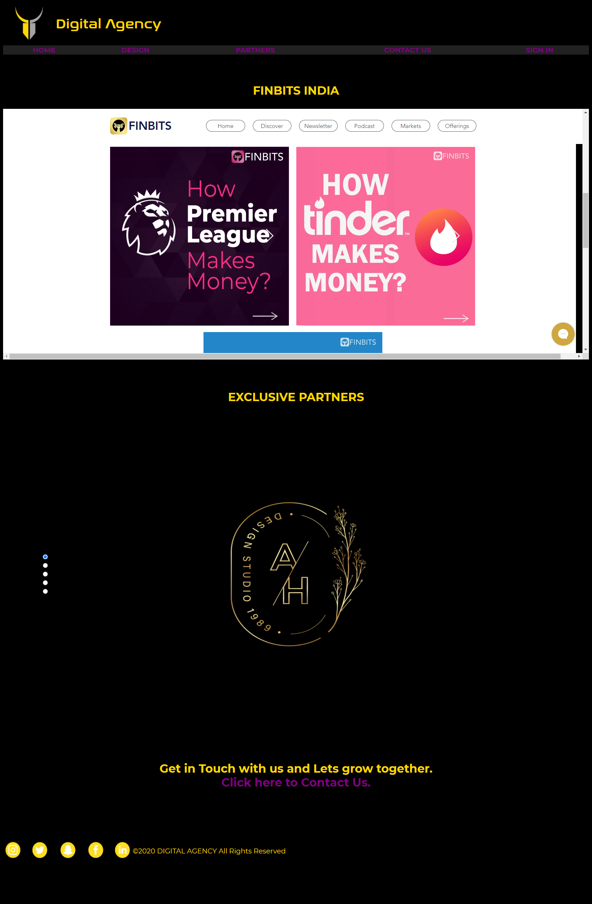

**Page 5:**



**Short description of each web page:**

**Page 1:**

Page 1 Lets you to register for the website and those values get stored in the database for future reference. You will get two options to sign up, which will redirect you to the home page.

**Page 2:**

Page 2 is the Home Page that gives you a brief description on what this agency is working on and how you can benefit from the services that we offer.

**Page 3:**

Page 3 offers you an exclusive look at our designing work and what our team is capable of implementing and presenting to the end consumer. It’s the design page.

**Page 4:**

Page 4 is the Partners page that offers an in-depth look at the clients that we handle and support. It showcases our reach.

**Page 5:**

Page 5 is the Contact Us page that helps you as a user to communicate directly with us and get your hands on any personalised design. It will also offer you a newsletter.

**Conclusion:**

Main goal of this website was to connect a team of skilled designers to the consumer who wants his/her dreams of great and creative graphics to be personalised and fulfilled. This website makes use of HTML, CSS, Javascript, PHP, MySQL to implement the frontend and the backend needs of the website.